**Cloud-hosted Banking Data Analytics and Reporting System on AWS**

## **Introduction**

HWzMas6ze5BHKjfdGyrR

## Empowering financial institutions to make informed decisions and enhance operational efficiency is the primary goal of "Cloud Bank Analytics", a comprehensive cloud-based banking data analytics and reporting system. This platform optimizes financial data processing, analysis, and visualization, thereby streamlining banking operations.

## **Technical Infrastructure**

## The robust and scalable infrastructure of "Cloud Bank Analytics" is made possible by Amazon Web Services (AWS). Secure and efficient data storage is ensured through Amazon RDS, while AWS Elastic Beanstalk provides reliable web application hosting. Furthermore, AWS Lambda automates data processing and report generation, thereby enhancing productivity.

## **User Interface and Experience**

## Flask has been utilized to build a user-friendly web interface, which offers bank administrators a seamless experience. A personalized dashboard is presented to users upon logging in, serving as a central hub for all banking analytics activities. Real-time financial data, key performance indicators (KPIs), and custom report generation options are prominently featured on this intuitive dashboard.

## **Benefits and Goals**

## The combination of modern cloud technology and an intuitive user interface in "Cloud Bank Analytics" enables financial institutions to monitor customer behavior, manage risk, and ensure regulatory compliance effectively. By improving decision-making and operational efficiency, this platform helps banks thrive in a rapidly evolving financial landscape.

## **Scenarios**

## **Scenario 1: Real-time Transaction Monitoring**

## Sarah's morning routine begins with a login to Cloud Bank Analytics, where she's promptly alerted to suspicious transaction patterns detected during the night. The real-time analytics feature enables her to swiftly scrutinize the flagged transactions, verify the potential fraud attempt, and take swift action to protect compromised accounts. This timely intervention is made possible by Cloud Bank Analytics' advanced monitoring capabilities.

### **Scenario 2: Custom Report Generation**

### With the board meeting looming, John leverages Cloud Bank Analytics' custom report generation feature to create a comprehensive quarterly report. By selecting key performance indicators such as loan performance, deposit growth, and customer acquisition rates, John is able to distill complex data into actionable insights. The report, generated through the seamless integration of AWS Lambda and Amazon RDS, provides stakeholders with a clear understanding of the bank's financial performance.

### **Scenario 3: Regulatory Compliance Monitoring**

### Lisa relies on Cloud Bank Analytics to ensure the bank's regulatory compliance, leveraging a specialized dashboard that tracks key metrics in real-time. As she monitors the dashboard, Lisa identifies potential compliance issues before they become major problems. By drilling down into the underlying data, Lisa uncovers the root causes of these issues and implements corrective actions, thereby maintaining the bank's commitment to regulatory compliance.

### **Architecture:**

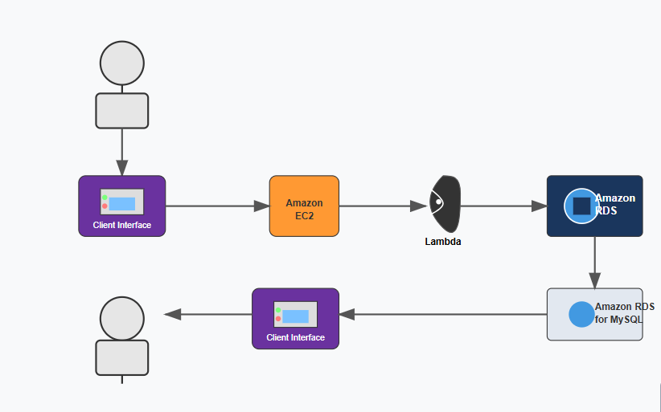

#### **Prior Knowledge:**

1. AWS Account Setup: <https://youtu.be/SZwrMyESSuk?si=kkYVbHkQsDYFf0O32>
2. Web Application Stack :

[FLask](https://www.youtube.com/results?search_query=flask+tutorial) || [MySQL Connector using flask](https://www.youtube.com/results?search_query=mysql+connector+for+flask) || [HTML/JS/CSS](https://www.youtube.com/results?search_query=html+js+css+tutorial+)

1. AWS EC2 Instance: <https://youtu.be/86Tuwtn3zp0?si=Kzn0zraucZVV5S7ORDS>
2. Database:

<https://youtu.be/QY4bVNL_yrI?si=st6-iZFVlVz0Hyv9>

1. RDS to MySQL:
2. <https://youtu.be/by0EJ4qL8ek?si=7XhzVSK6BP3HkLBO>
3. Clone Git repo:

<https://youtu.be/-PzIkfa2HEk?si=98y15yoy5-oXpeUf>

AWS Cost Management: <https://youtu.be/OKYJCHHSWb4?si=aY3DQl1v26CfZxXA>

1. AWS IAM:

<https://www.youtube.com/results?search_query=aws+iam>

1. AWS CloudWatch:

<https://www.youtube.com/results?search_query=aws+cloudwatch>

#### **Project Flow:**

**Project Initialization:**

To kick-start the project, objectives, scope, and key performance indicators (KPIs) were clearly defined. Additionally, the AWS environment was set up to provide a solid foundation for the project.

**EC2 Instance Setup:**

A new EC2 instance was launched and meticulously configured to serve as the host for the web application, ensuring a robust and reliable infrastructure.

**RDS Database Setup:**

An RDS instance was created and configured with the MySQL engine, providing a secure and efficient database solution for storing and managing data.

**Web Application Development:**

The web application was developed with a range of features, including user registration, secure login functionality, and a customizable dashboard, to provide a seamless and intuitive user experience.

## **Database Integration:**

## To facilitate seamless data exchange, the web application was connected to the RDS database using specialized drivers, ensuring a robust and reliable data integration.

## **User Interface Implementation:**

## Intuitive and user-friendly interfaces were designed and implemented for key features such as registration, login, and blood request management, providing an enhanced user experience.

## **Testing and Optimization:**

## A comprehensive testing regimen was conducted to ensure all features functioned as intended, followed by optimization efforts to fine-tune performance, resulting in a stable and efficient system.

## **Milestone 1: AWS Account Creation**

In this milestone, we will establish an AWS account to access the necessary services for the Banking System project.

**Activity 1: Create AWS Account**

To create an AWS account, follow these steps:

1. Visit the AWS website and initiate the account creation process by clicking on the "Create an AWS Account" button.

2. Enter your email address and create a password to secure your account.

3. Provide essential account information, including your full name, address, and phone number.

4. Add your payment details, noting that a credit card is required for verification purposes, although AWS offers a free tier.

5. Complete the identity verification process to validate your account.

6. Select a support plan, with the basic plan being free and sufficient for initial use.

7. Once the account setup is complete, sign in to access your new AWS account.

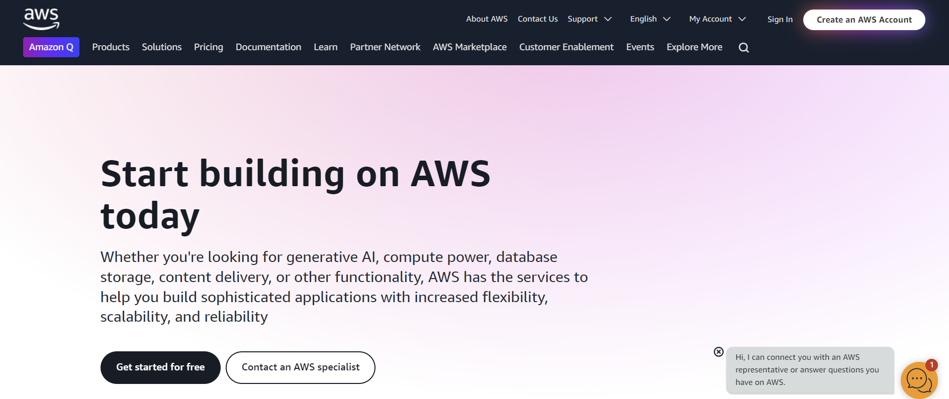

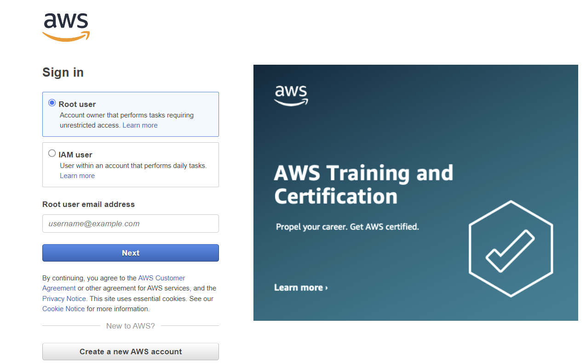

**Activity 2: Set Up IAM Users and Permissions**

To configure Identity and Access Management (IAM) users and permissions, follow these steps:

1. Navigate to the IAM console through the AWS Management Console to manage access and permissions.

2. Establish a new IAM user account for yourself, granting administrative privileges to facilitate seamless management.

3. Enhance account security by configuring multi-factor authentication (MFA), providing an additional layer of protection.

4. Create a designated group for developers, assigning requisite permissions to ensure they have necessary access to resources.

5. If programmatic access is required, generate access keys to enable secure and controlled interaction with AWS services**.**

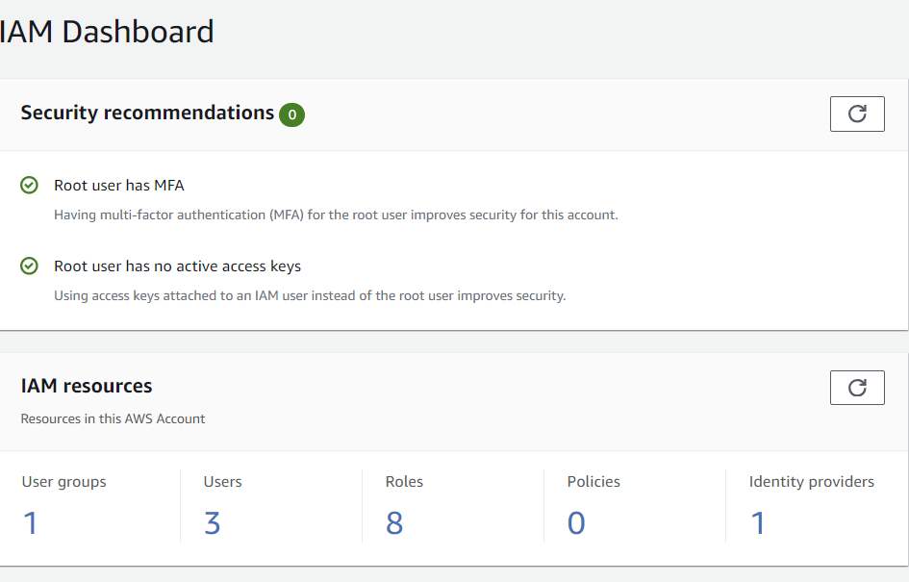

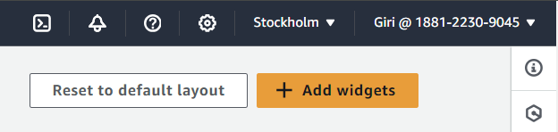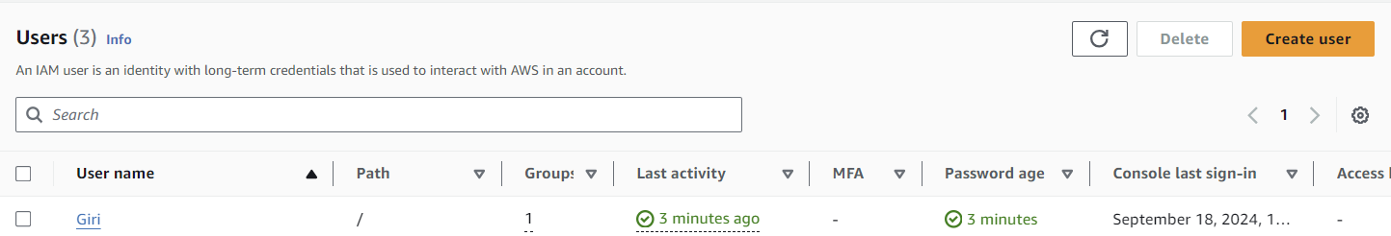

#### **Milestone 2: Local Development Environment Setup**

In this milestone, we will set up a local development environment to support the development of the ABC bank project.

**Activity 1: Set Up Local Development Environment:**

To establish a local development environment, complete the following steps:

1. Begin by installing Python and pip on your local machine to lay the foundation for your development environment.

2. Install the necessary Python packages, including Flask, flask-sqlalchemy, and mysql-connector-python, to support your project's requirements.

3. Configure a virtual environment specifically for your project to ensure dependency management and isolation.

**Activity 2: Create Flask Application Structure**

To create the foundation for your Flask application, follow these steps:

1. Create a new directory dedicated to your ABC bank project, providing a centralized location for your project files.

2. Establish a basic Flask application structure within the newly created directory, setting the stage for your application's development.

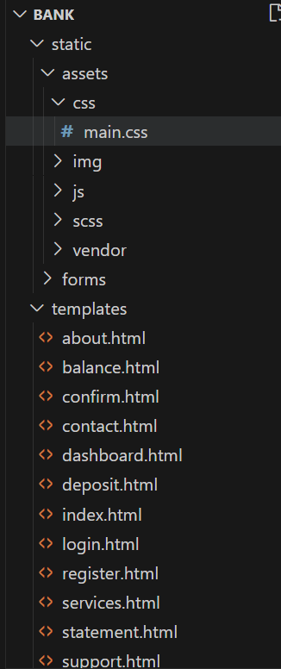

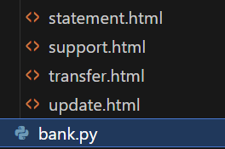

#### **Milestone 3: Develop ABC Bank Web Application**

In this milestone, we will develop the ABC Bank web application, creating a user-friendly interface and implementing the necessary functionality. This will involve designing and creating web pages, implementing Flask routes and views, and adding form handling for user input.

**Activity 1: Create Web Pages**

To create the web pages for the banking application, follow these steps:

1. Design and develop HTML templates for the following pages: home, user registration, login, account dashboard, transaction, account creation, check balance, deposit, services, contact, confirm, account login, and statement.

2. Organize these templates within the templates/ directory.

3. Develop CSS files within the static/css/ directory to apply styling to the web pages.

4. Add JavaScript files to the static/js/ directory as needed to support dynamic functionality.

**Activity 2: Implement Flask Routes and Views**

To implement the necessary Flask routes and views, complete the following steps:

1. Within the app.py file, define Flask routes for each web page in Activity 1.

2. Develop view functions to render the corresponding templates for each route.

3. Implement form handling to process user input for registration, login, transactions, and other relevant interactions.

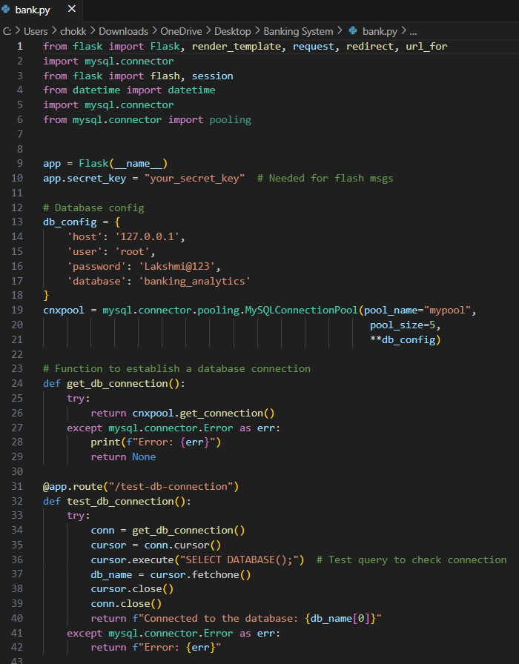

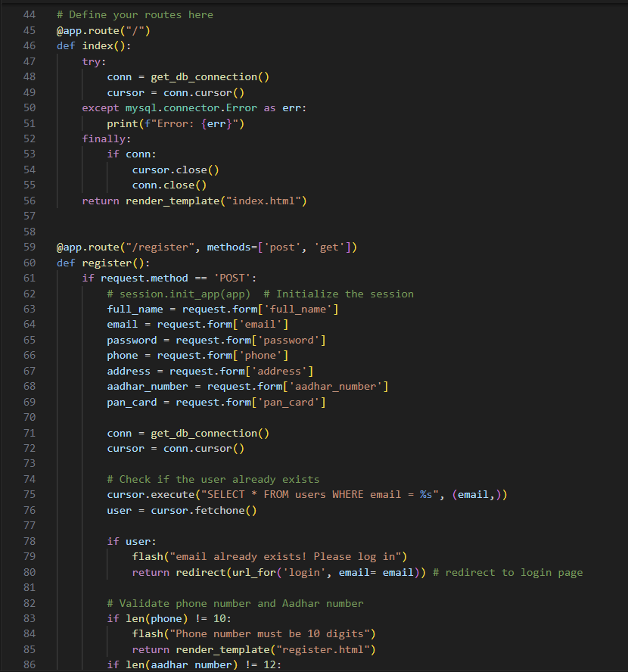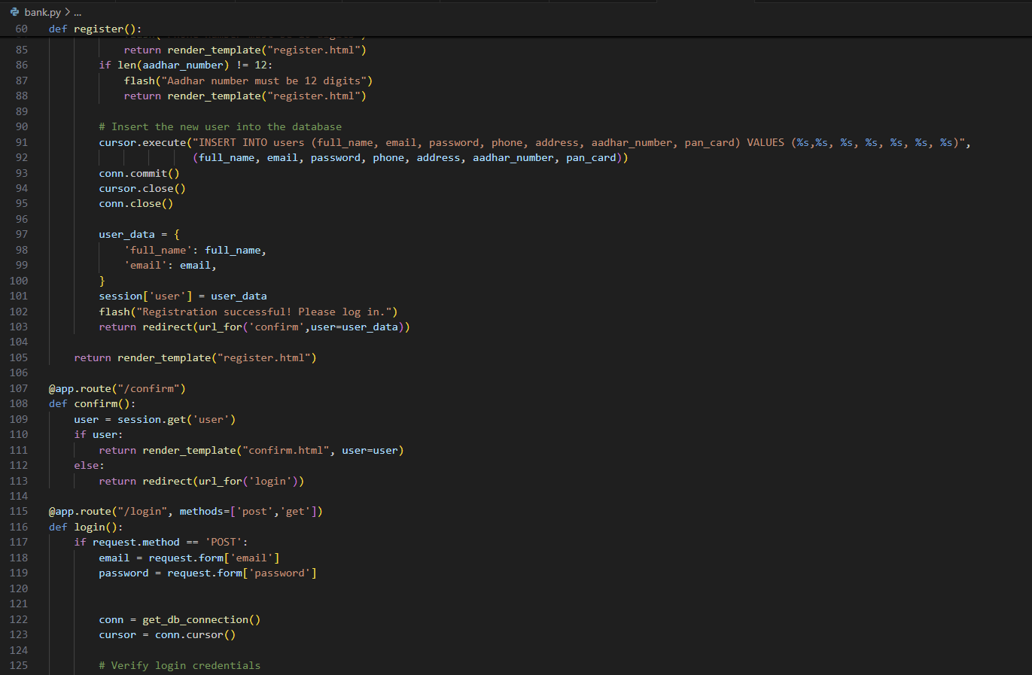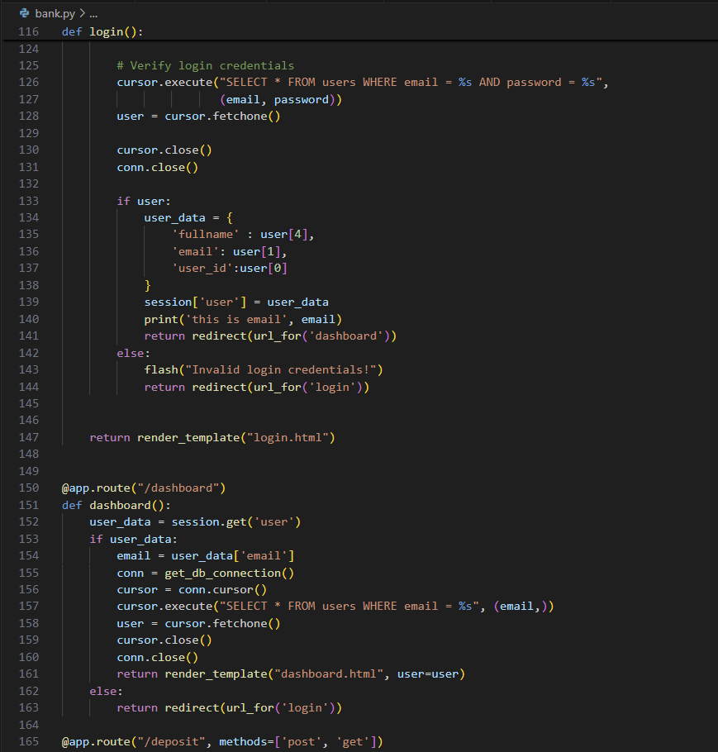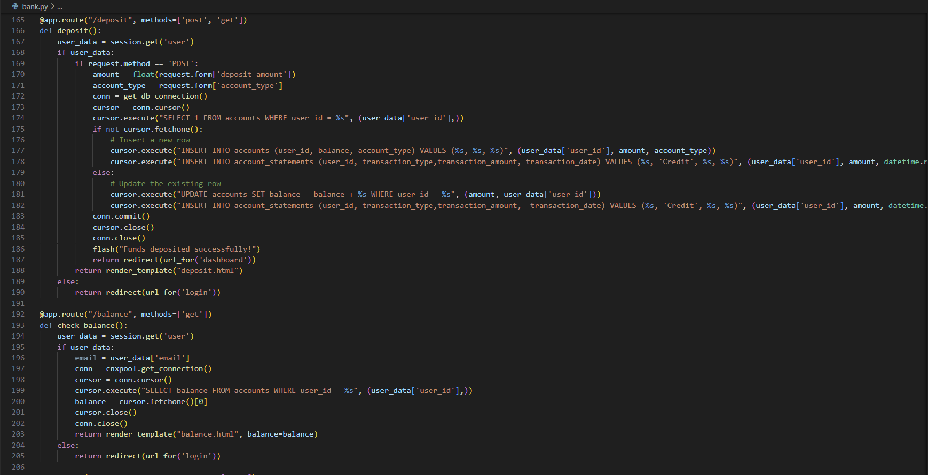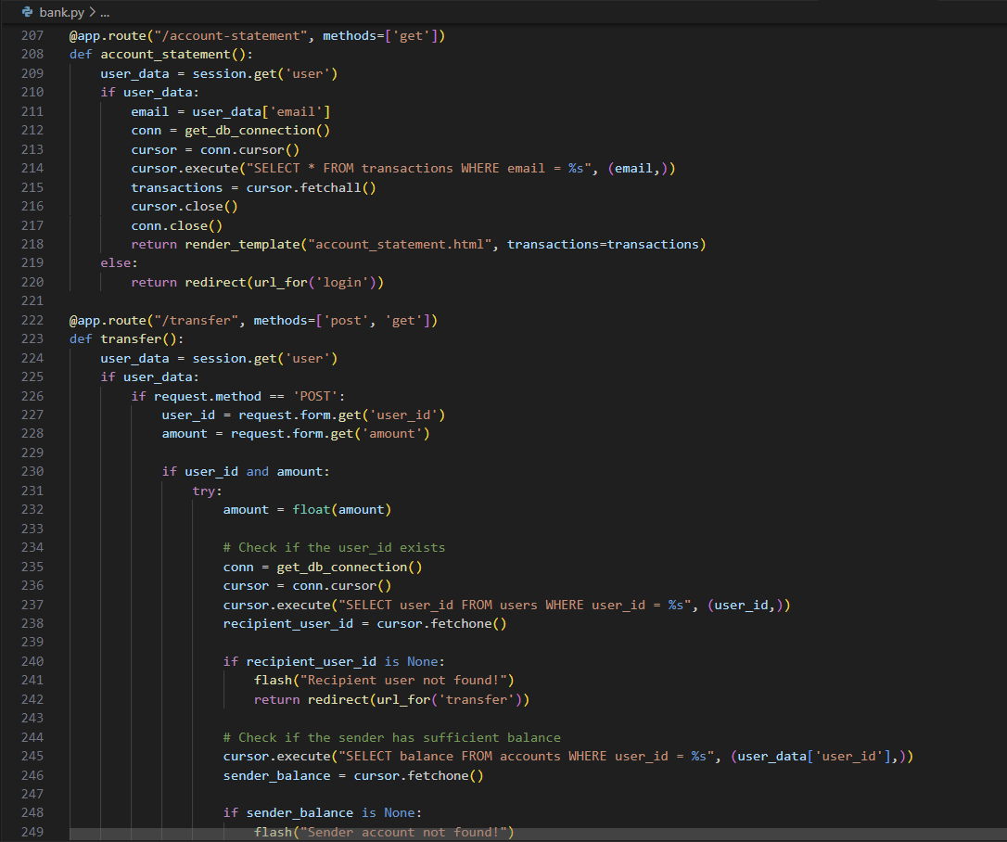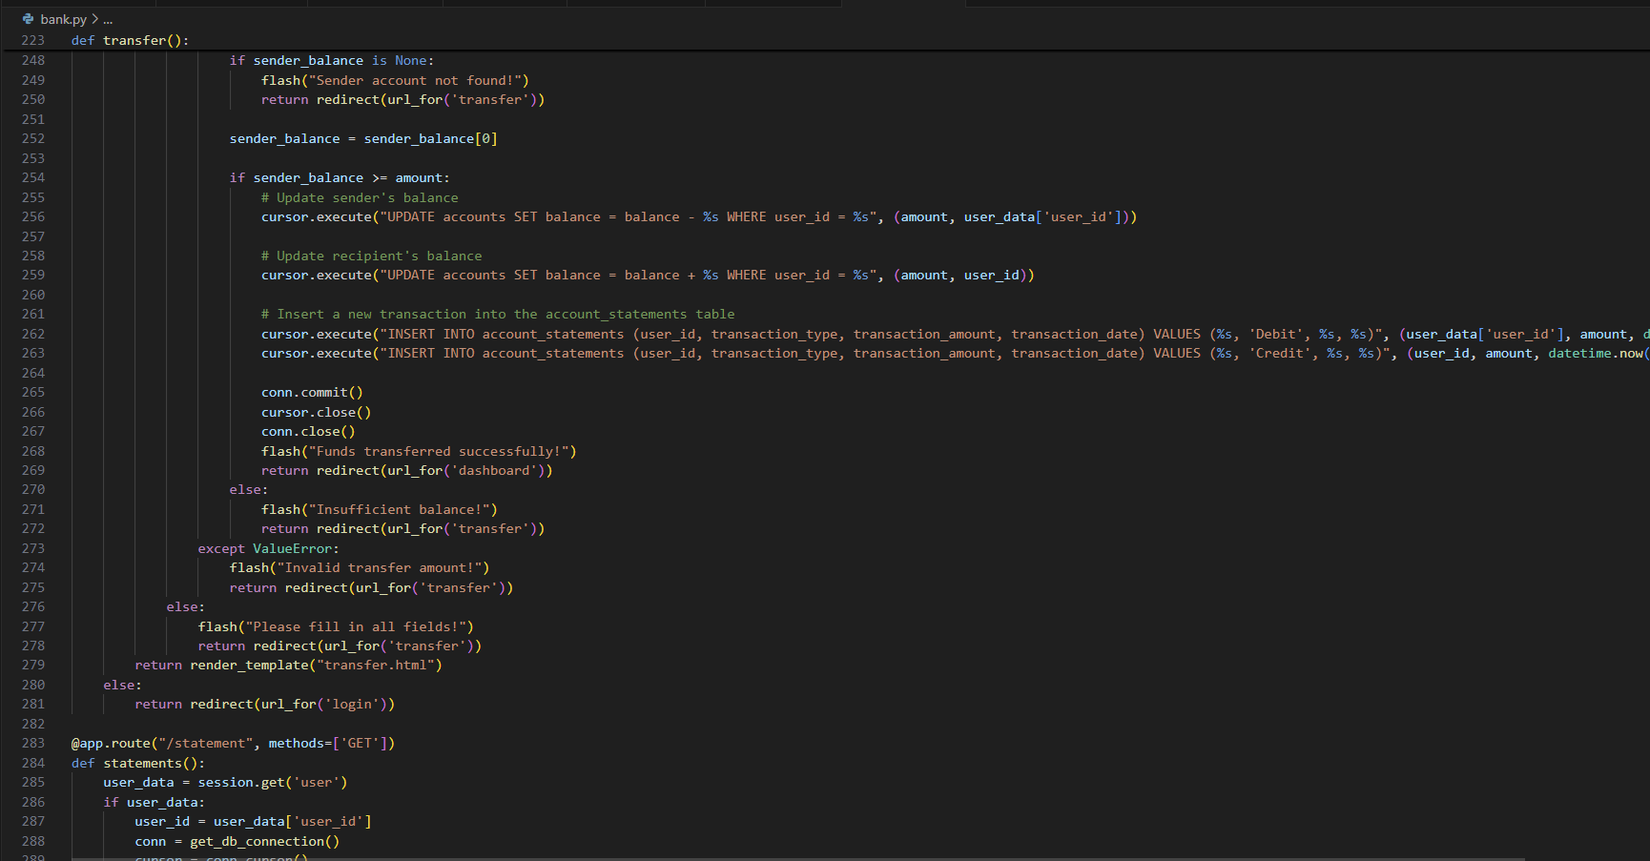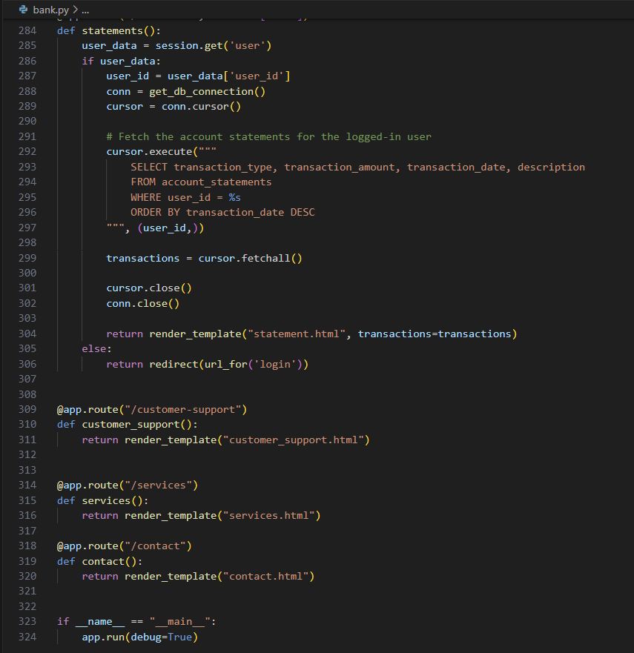

**Milestone 3: AWS RDS Setup and MySQL Integration**

In this milestone, we will set up an Amazon RDS instance and integrate it with MySQL to support the banking application's database requirements. This involves creating a new RDS instance, configuring its settings, and noting down essential connection details.

**Activity 1: Create Amazon RDS Instance:**

To create a new Amazon RDS instance, follow these steps:

1. Navigate to the RDS Console from the AWS Management Console to initiate

the instance creation process.

2. Launch a new RDS instance, selecting MySQL as the database engine and choosing an instance size suitable for testing, such as db.t3.micro.

3. Configure the instance's storage settings, network configuration, and security groups to ensure proper access and security.

4. Set up the master username and password for the RDS instance, and ensure that connections are allowed from your local IP address for development and testing purposes.

5. Record the instance's endpoint, port, database name, username, and password for future reference.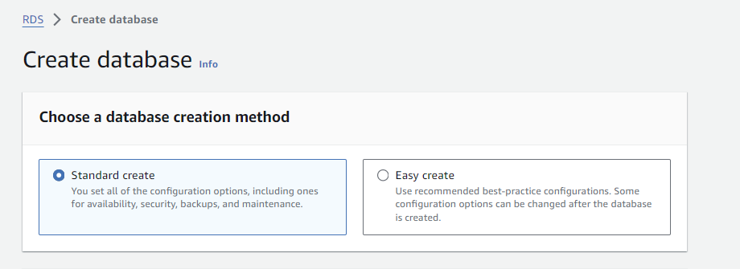

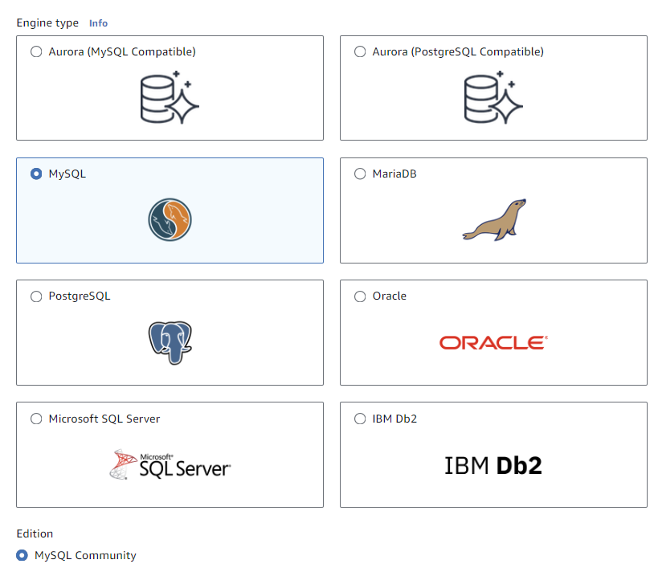

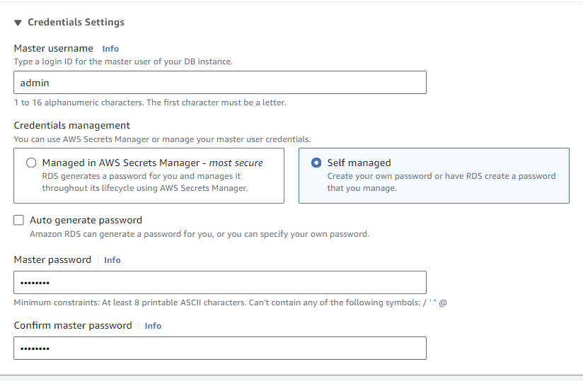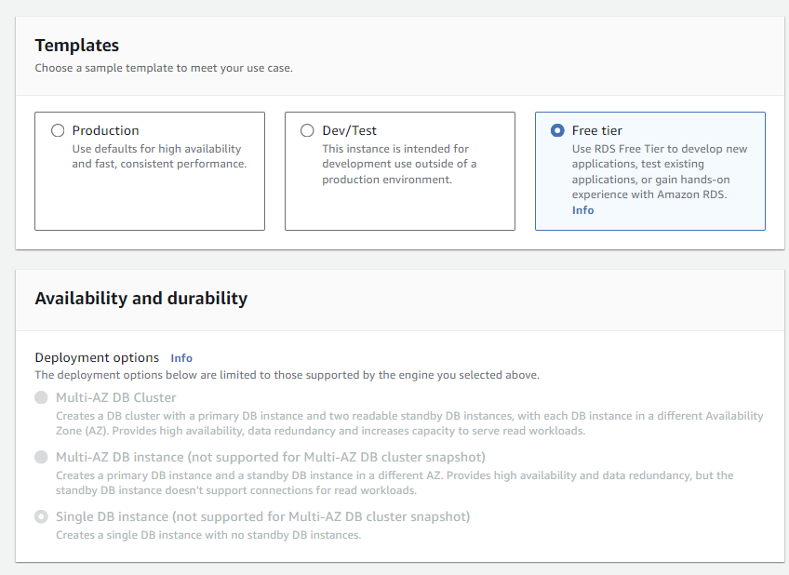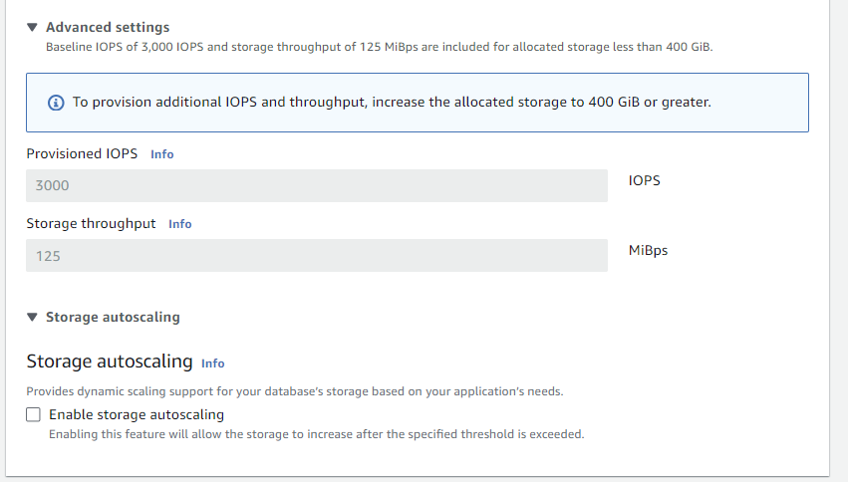

**Activity 2: Connect to RDS using MySQL Client**

To establish a connection to your RDS instance using the MySQL client, follow these steps:

1. Verify that the MySQL client is installed on your local machine; if not, proceed with the installation.

2. Utilize the following command to initiate a connection to your RDS instance, substituting the placeholders with your actual RDS endpoint, username, and password:

mysql -h <your-rds-endpoint> -P 3306 -u <your-username> -p

3. When prompted, enter your RDS master password to complete the authentication process and establish a secure connection.

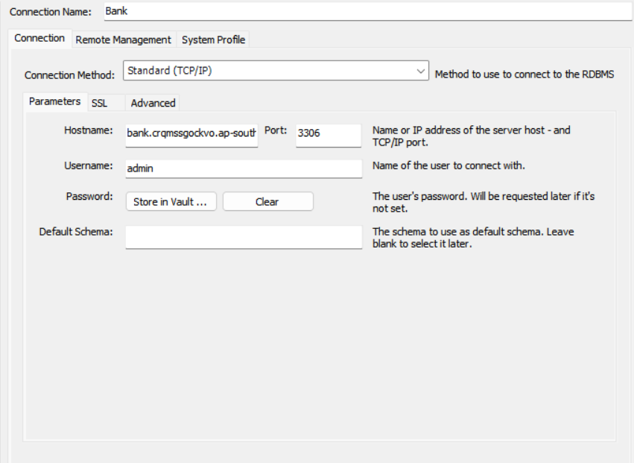

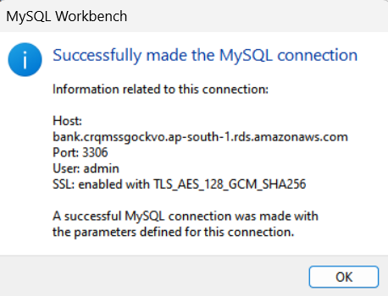

**Milestone 4: EC2 Deployment**

In this milestone, we will deploy our application to an Amazon Elastic Compute Cloud (EC2) instance, providing a scalable and secure environment for our banking system. This involves launching a new EC2 instance, configuring its settings, and ensuring proper security measures are in place.

**Activity 1: Launch EC2 Instance**

To launch a new EC2 instance, follow these steps:

1. Navigate to the EC2 Console from the AWS Management Console to initiate the instance launch process.

2. Launch a new EC2 instance, selecting an Amazon Linux 2 AMI as the operating system and choosing an instance type suitable for testing, such as t2.micro.

3. Configure the instance details, specifying the virtual private cloud (VPC) and subnet for the instance, and add storage as necessary.

4. Configure the security group settings to allow incoming traffic on SSH (port 22) and HTTP/HTTPS (ports 80/443), ensuring secure access to the instance.

5. Create a new key pair or select an existing one to enable secure SSH access to the EC2 instance.

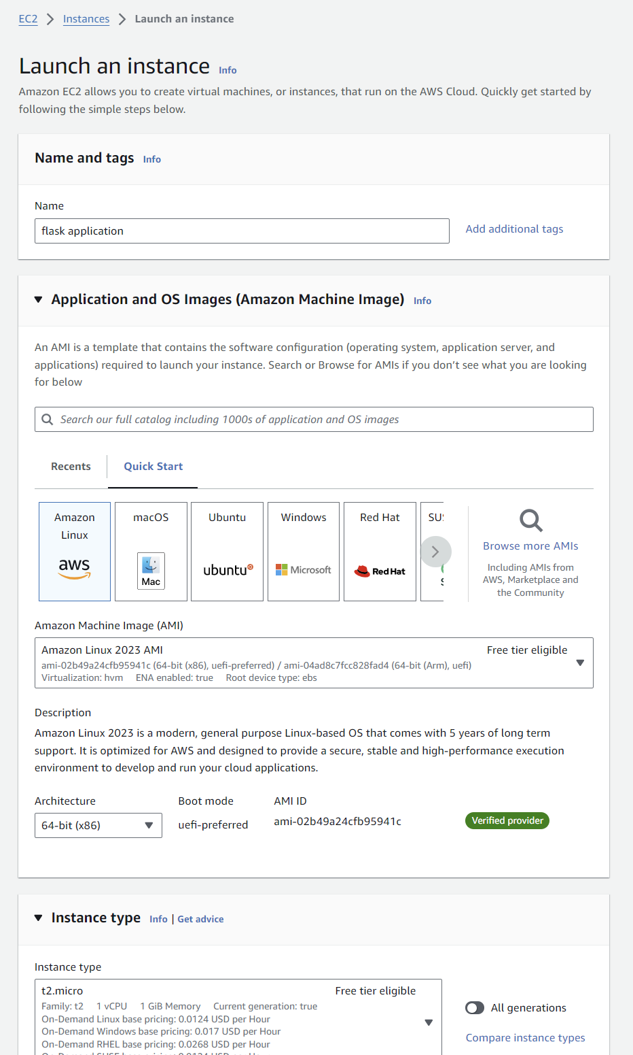

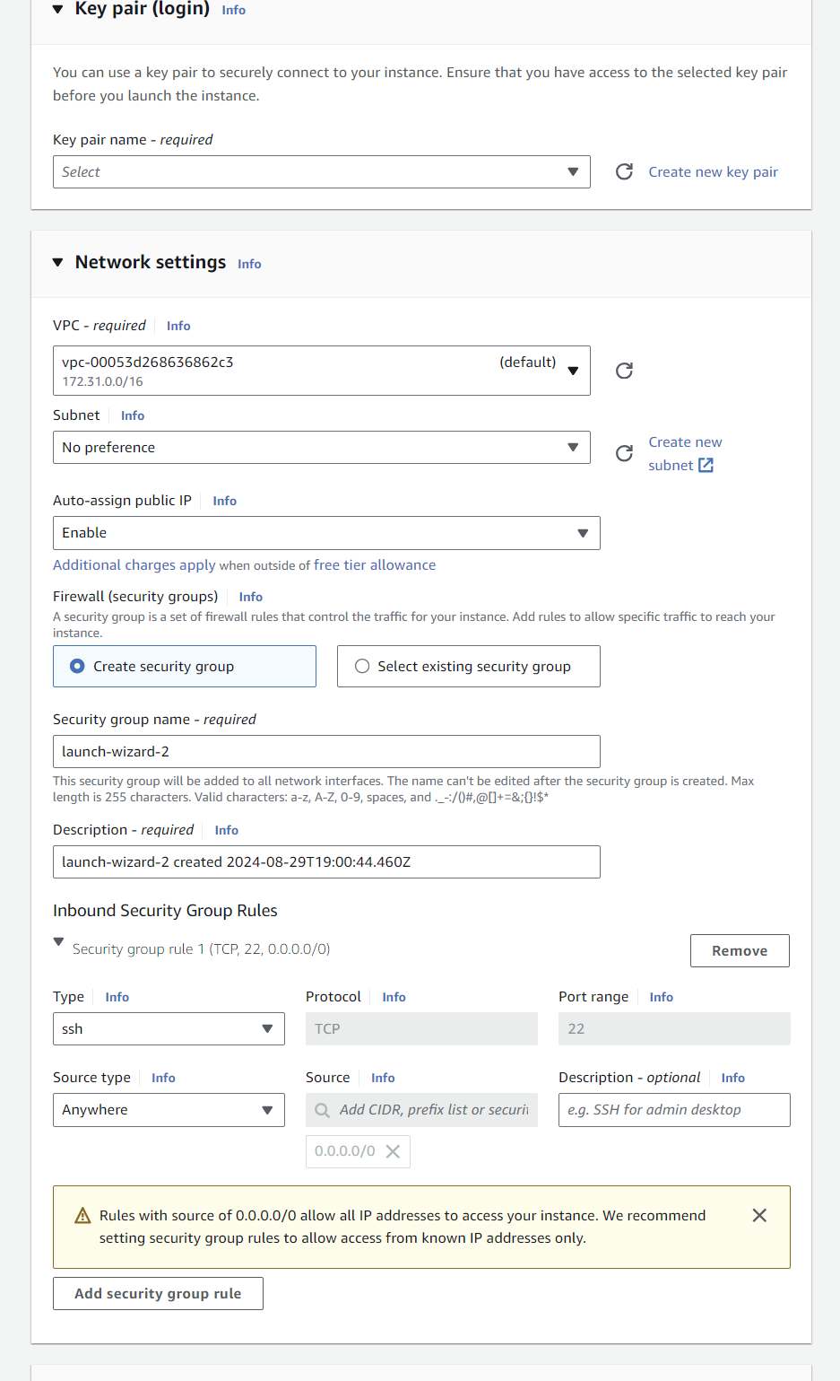

**Activity 2: Configure EC2 Instance**

To configure your EC2 instance, follow these steps:

1. Establish a secure connection to your EC2 instance using SSH.

2. Update the system and install necessary software by running the following commands: sudo yum update -y and sudo yum install python3 python3-pip mysql -y.

3. Install the required Python packages.

**Activity 3: Deploy Flask Application to EC2**

To deploy your Flask application to the EC2 instance, follow these steps:

1. Transfer your application code to the EC2 instance.

2. Set up any necessary environment variables, including database connection strings.

3. Configure the web server to serve your application

4. Start your application and ensure it's accessible via the EC2 instance's public IP or domain.

5. Run the following commands in the EC2 terminal:

- sudo yum update -y

- sudo yum install python3 -y

- sudo pip3 install virtualenv

- python3 -m venv venv

- source venv/bin/activate

- pip install flask

- git clone https://github.com/your-repo/your-flask-app.git

- cd your-flask-app

- python3 app.py

#### **Milestone 5: Monitoring and Management**

In this milestone, we will set up monitoring and management tools to ensure the reliability, performance, and security of our ABC Bank application. This involves configuring CloudWatch monitoring, setting up alarms, and tracking key metrics.

**Activity 1: Set Up CloudWatch Monitoring**

To set up CloudWatch monitoring, follow these steps:

1. Access the CloudWatch console from the AWS Management Console.

2. Create a new dashboard for your ABC Bank application.

3. Add widgets to monitor key metrics, including:

- EC2 instance CPU utilization, network traffic, and status checks

- RDS instance CPU utilization, free storage space, and database connections

- Application-specific metrics (e.g., number of transactions, active users)

4. Set up CloudWatch Alarms for critical thresholds (e.g., high CPU usage, low free storage).

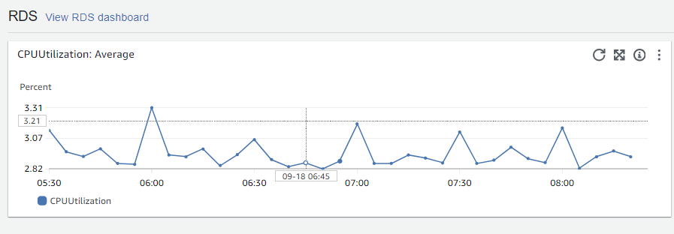

**Activity 2: Configure CloudWatch Logs**

To set up CloudWatch Logs for your application, complete the following steps:

1. Install and configure the CloudWatch Logs agent on your EC2 instance to enable log collection and transmission to CloudWatch.

2. Organize your logs by creating log groups for specific categories, including:

- Application logs: containing logs generated by your application

- EC2 system logs: containing system-level logs from your EC2 instance

- Nginx logs (if applicable): containing logs generated by the Nginx web server

3. Define log filters to extract and analyze critical log events, enabling you to identify trends, diagnose issues, and optimize your application's performance.

**Milestone 6: Testing, Optimization, and Maintenance**

In this milestone, we will ensure the reliability, performance, and security of our ABC Bank application through thorough testing, optimization, and maintenance. This involves conducting functionality, security, and load testing, optimizing performance, implementing backup and disaster recovery, and continuously improving the application.

**Activity 1: Conduct Thorough Testing**

To ensure the application's quality and reliability, follow these testing steps:

1. Perform comprehensive functionality testing of all banking features to verify correct operation.

2. Conduct rigorous security testing, including penetration testing if possible, to identify vulnerabilities.

3. Execute load testing to ensure the application can handle anticipated traffic and maintain performance.

**Activity 2: Optimize Performance**

To optimize the application's performance, follow these steps:

1. Analyze and optimize database queries to improve data retrieval efficiency.

2. Implement caching mechanisms, such as Flask-Caching, to reduce computational overhead.

3. Optimize front-end assets by minifying CSS and JavaScript files, and compressing images.

**Activity 3: Implement Backup and Disaster Recovery**

To ensure business continuity, follow these steps:

1. Configure automated RDS snapshots to create regular database backups.

2. Develop a comprehensive disaster recovery plan, including procedures for failover to a different region if necessary.

**Activity 4: Continuous Improvement**

To maintain and improve the application continuously, follow these steps:

1.Regularly update EC2 instances and RDS with the latest security patches to

prevent vulnerabilities.

2. Monitor CloudWatch metrics and logs to identify areas for improvement and optimize resource utilization.

3. Collect user feedback and iterate on the application's features and user experience to enhance overall quality.

4. Continuously optimize AWS resource usage to ensure cost-effectiveness and efficiency.

**INDEX.HTML:**

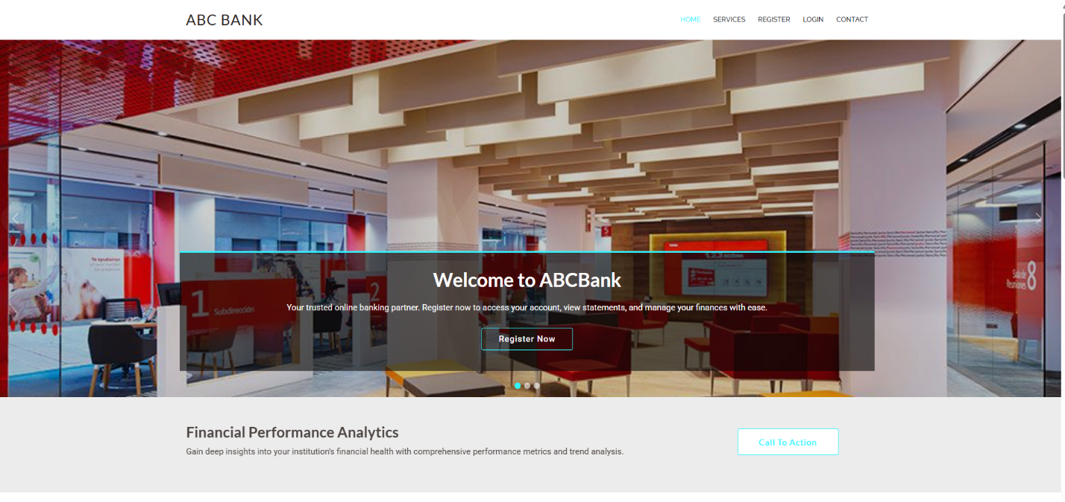

**SERVICE.HTML:**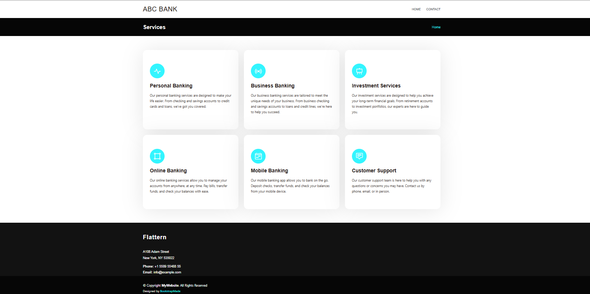

**LOGIN.HTML:**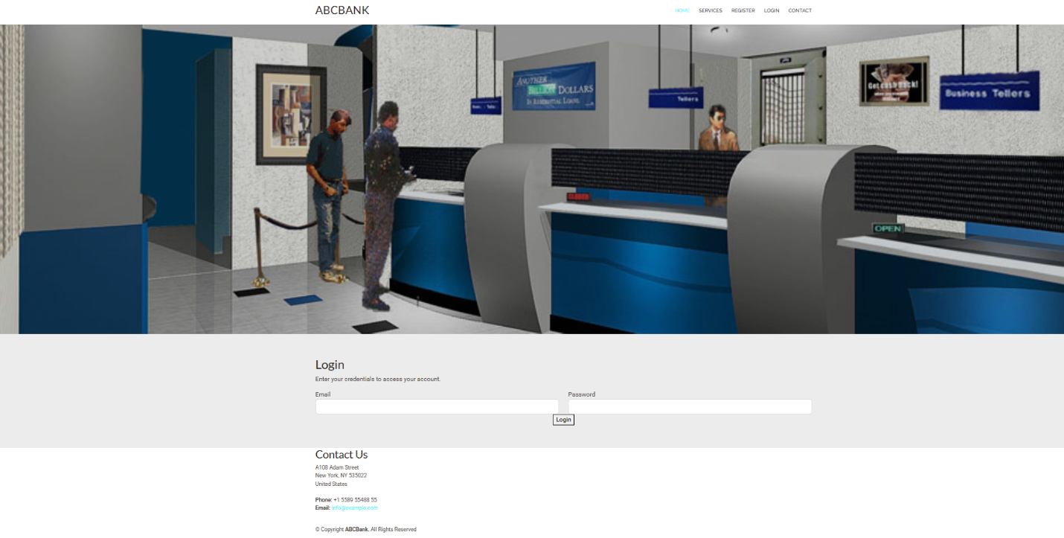

**REGISTER.HTML:**

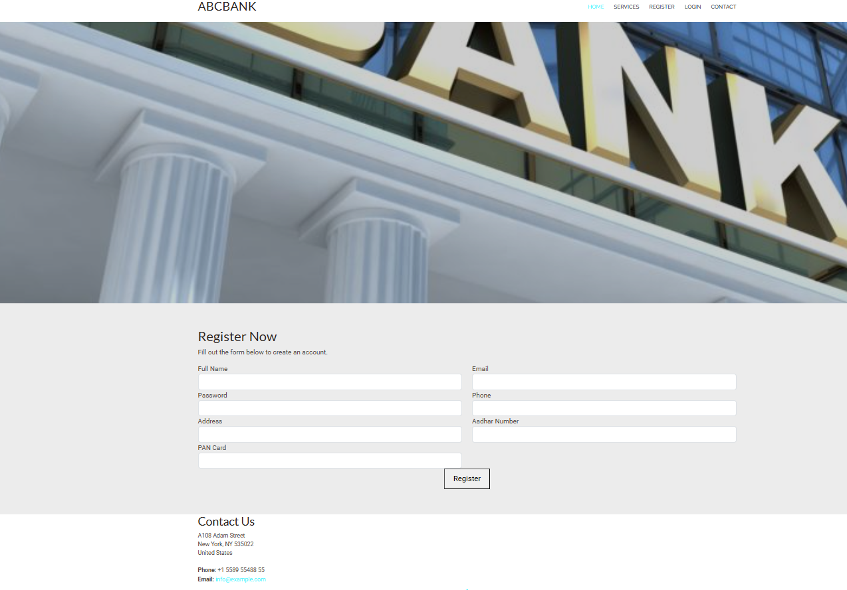

**BALANCE.HTML:**

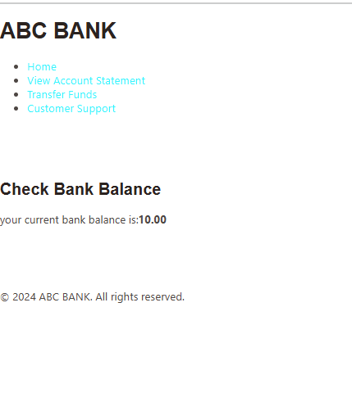

**DASHBOARD.HTML:**

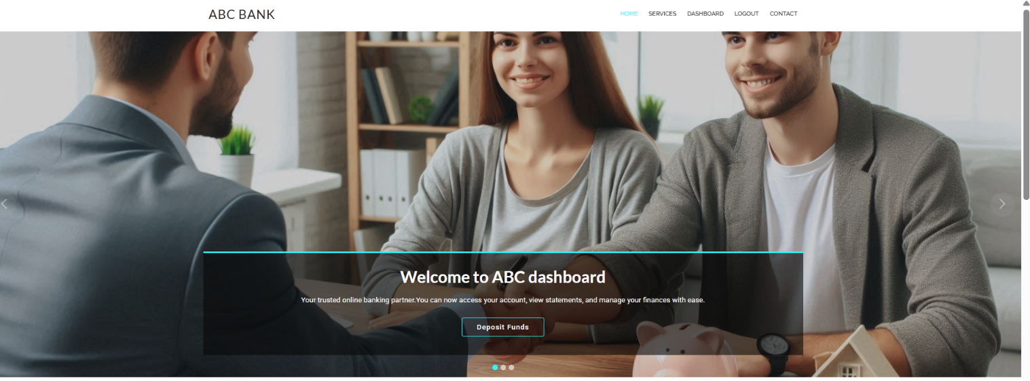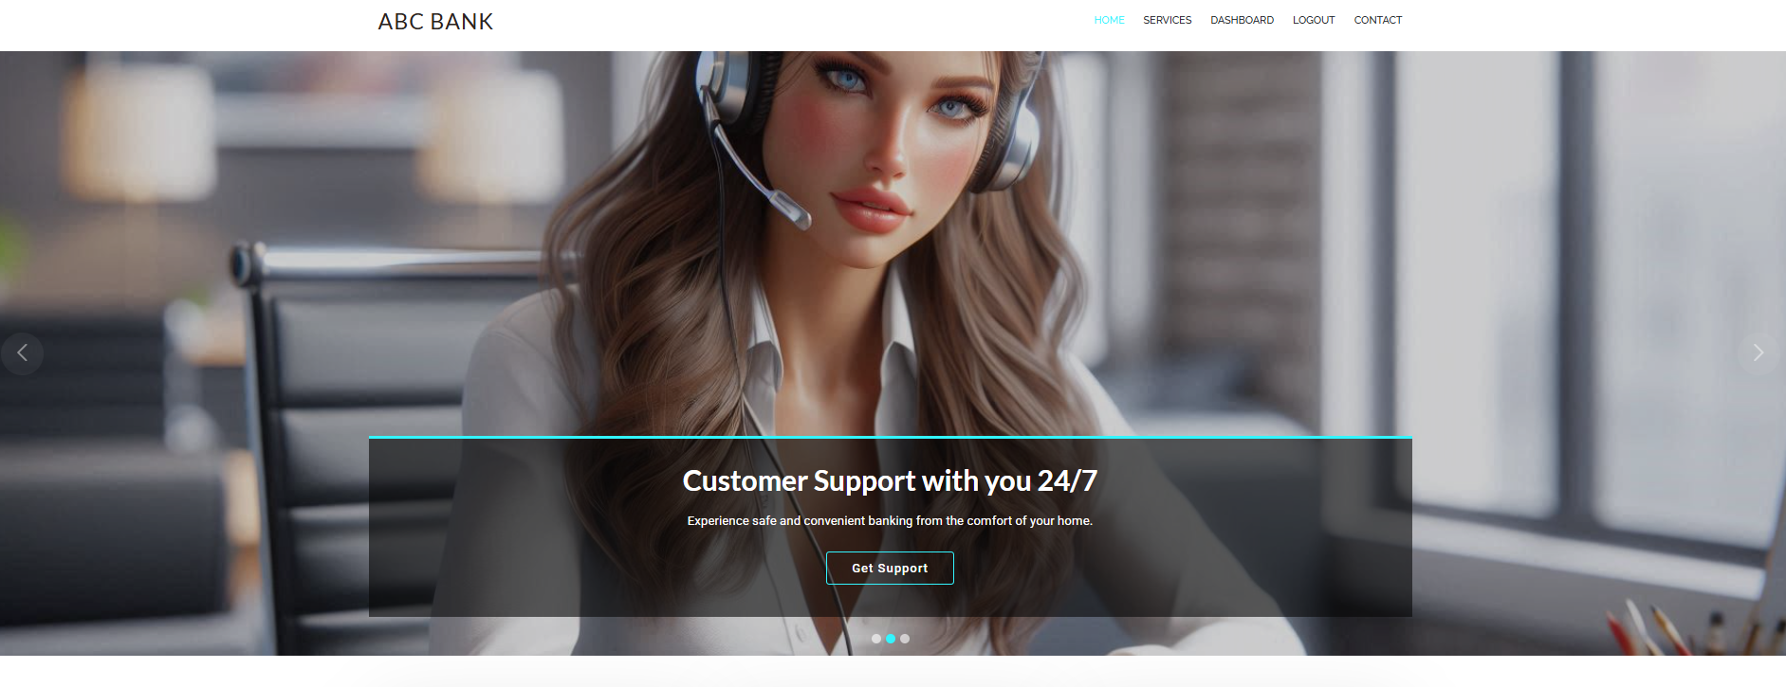

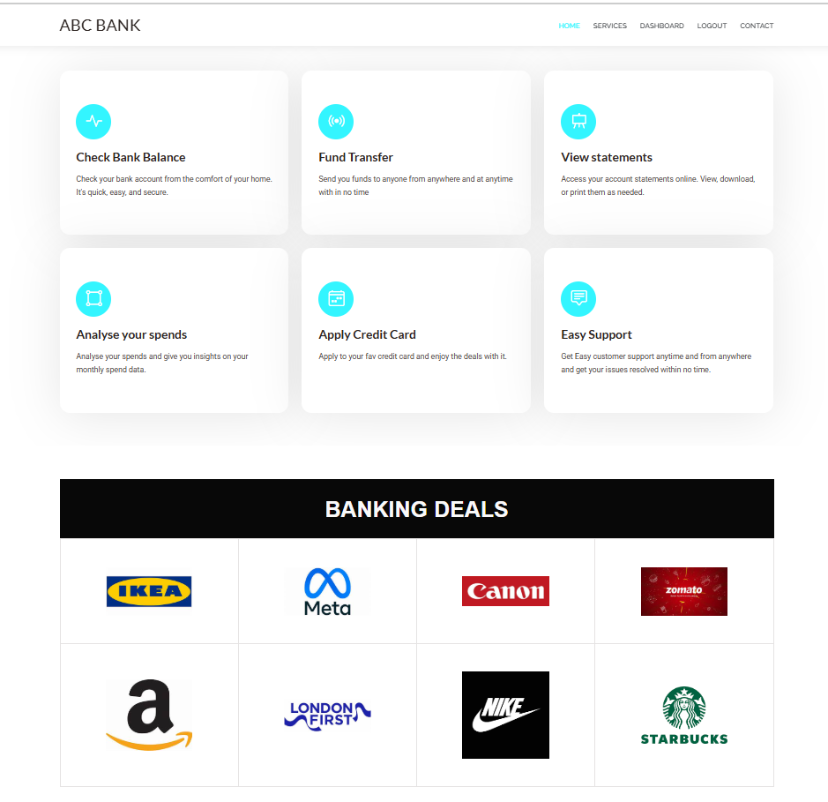

**STATEMENTS.HTML:**

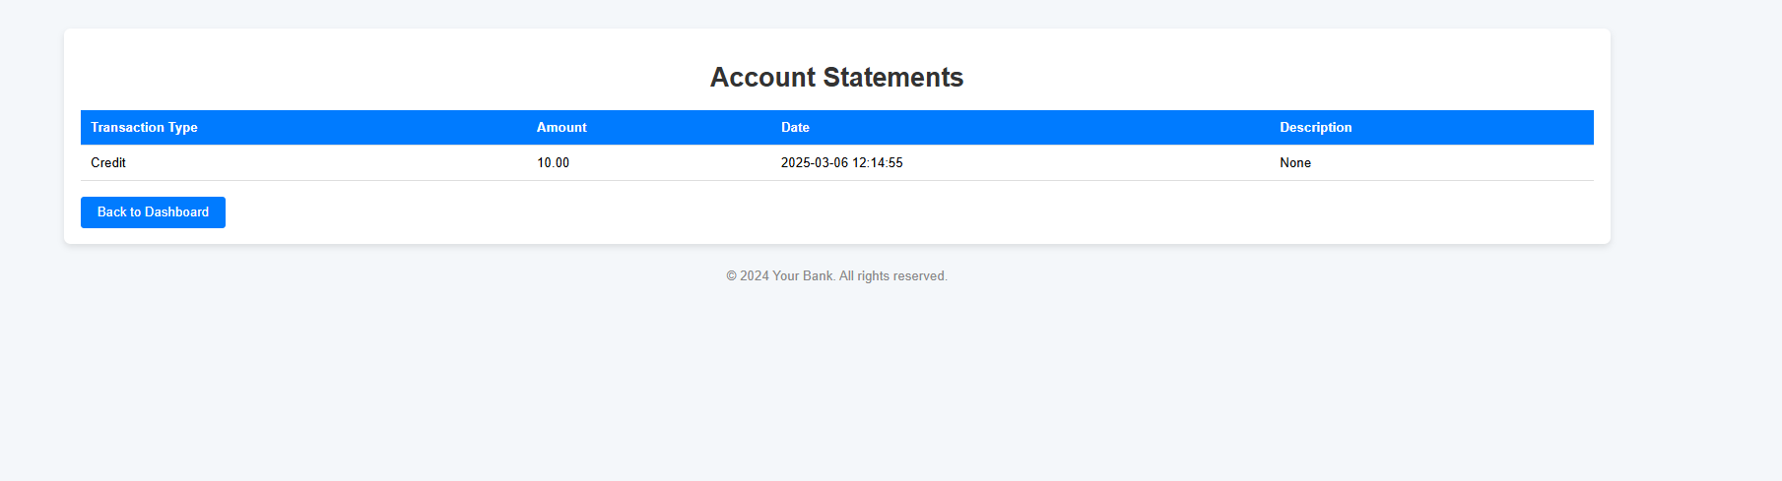

**CONTACT.HTML:**

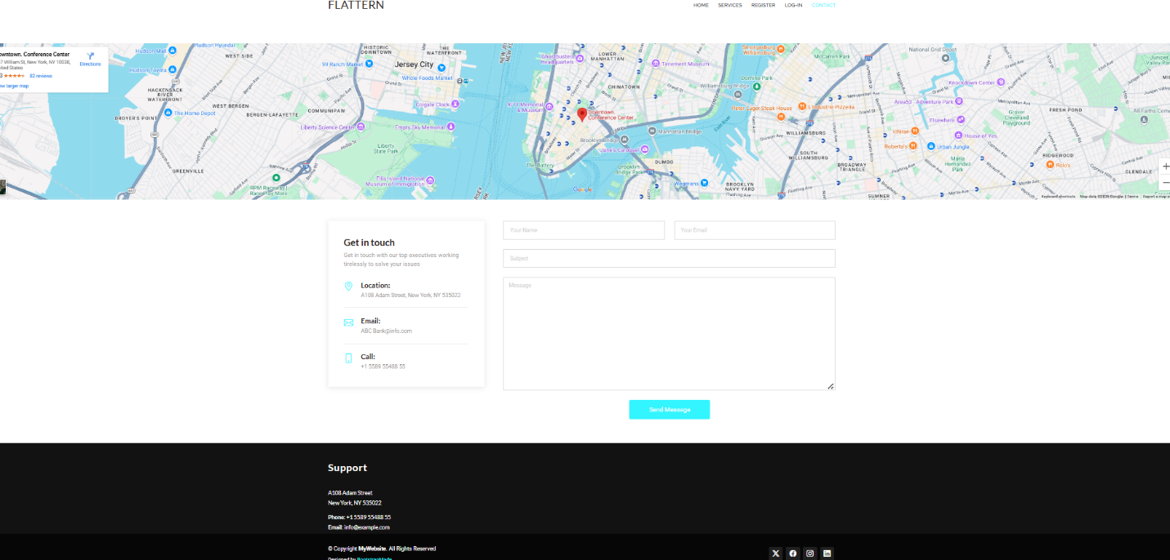

**DEPOSIT.HTML:**

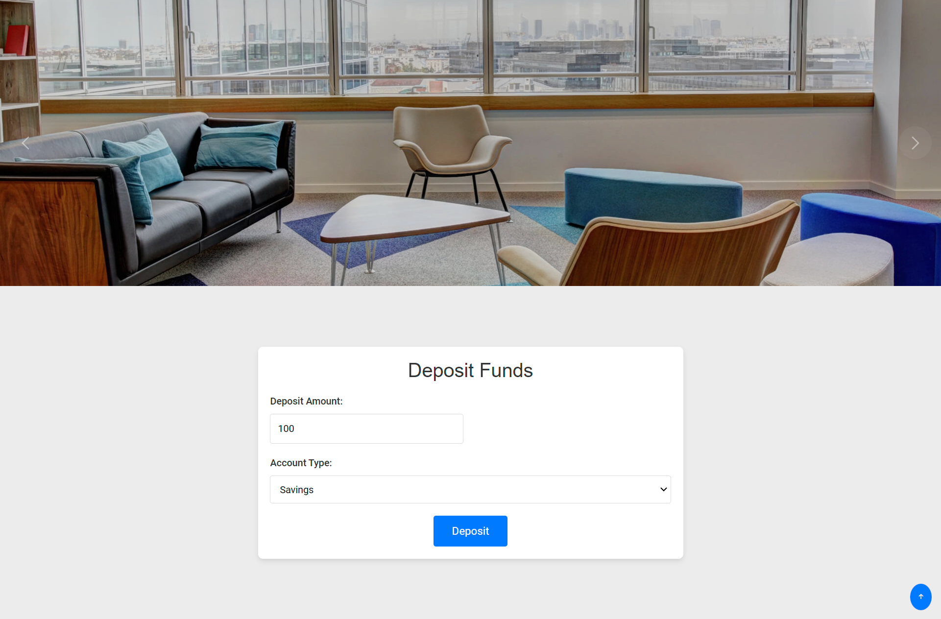

**TRANSFER.HTML:**

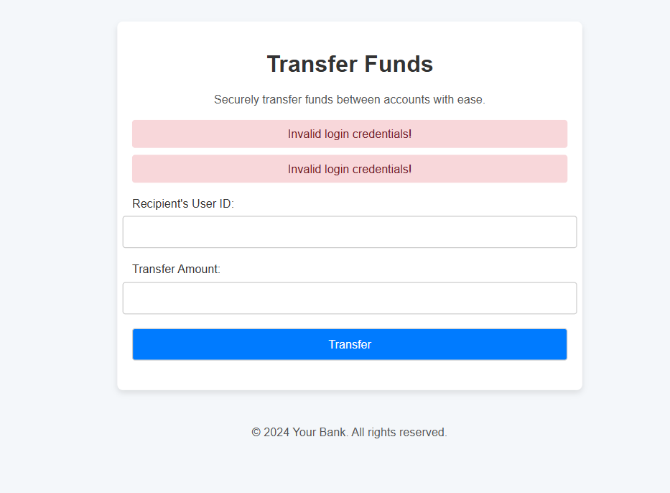

**CONCLUSION:**

The ABC Bank project marks a significant milestone in the development of cloud-based banking systems, demonstrating a robust, scalable, and secure framework. Leveraging AWS services, this project showcases a dynamic platform capable of adapting to the evolving demands of modern banking.

Beyond its technical accomplishments, this project highlights the intricacies and considerations involved in developing cloud-based financial applications. As the financial sector continues to digitize, initiatives like ABC Bank are spearheading innovation in secure, user-friendly banking solutions.

The expertise gained and architectural framework developed in this project provide a valuable foundation for future fintech endeavors and cloud-based applications in sensitive industries, driving progress and excellence.